GLOBAL TRENDS IN URBANIZATION, AGRICULTURE AND SMALLHOLDER FARMING

Peter B. R. Hazell

**Some Basic Trends in Urbanization**

In 2014, the urban population is estimated to have reached 40% of the population in Africa, 47.5% in Asia, and 79.5% in LAC (Table 1). The UN projects that urbanization will increase faster than total population in all three continents and by 2050 the urban population shares are expected to reach 55.9% in Africa, 64.2% in Asia, and 86.2% in LAC.

Continuing population growth and urbanization are projected to add 2.5 billion people to the world’s urban population by 2050, with nearly 90 per cent of the increase concentrated in Asia and Africa. By 2050, 82.4% of the world’s urban population will be based in less-developed regions.

Urbanization is not just about mega cities. In fact, close to half of the world’s urban dwellers reside in relatively small settlements of less than 500,000 inhabitants, while only around one in eight live in the 28 mega-cities with more than 10 million inhabitants. This has important implications for urban-rural linkages, enabling many households to combine farm and nonfarm activities, even when living in urban areas. Often they are living in areas that were previously defined as rural, and have become urban through census reclassification rather than any physical move.

Urbanization is leading to more diversified national diets with increased per capita demands for livestock and horticultural products and processed and pre-cooked foods, and reduced per capita demands for traditional food staples ( ).

Table 1: Trends in urban populations, 1970 to 2050, Africa, Asia and LAC

|  |  |  |  |  |  |
| --- | --- | --- | --- | --- | --- |
|  | 1970 | 1990 | 2014 | 2030 | 2050 |
| Urban population (millions) | | | | | |
| Africa | 87 | 197 | 455 | 770 | 1,339 |
| Asia | 506 | 1,036 | 2,064 | 2,752 | 3,313 |
| LAC |  | 314 | 496 | 595 | 674 |
| Urban population (percent) | | | | | |
| Africa | 22.6 | 31.3 | 40.0 | 47.1 | 55.9 |
| Asia | 23.7 | 32.3 | 47.5 | 56.3 | 64.2 |
| LAC | 57.1 | 70.5 | 79.5 | 83.0 | 86.2 |

Source: United Nations (2014)

**Some Basic Trends in the Distribution of Land**

Globally, there are more small farms than ever and the average size is declining (Table 2). At last count, FAO estimated there are about 570 million farms in the world, of which about 475 million (about 84%) are small (≤ 2 ha) (Lowder et al., 2014). About 92% of all farms are located in developing countries. Small farms are predominantly concentrated in Asia and Africa and are home to some 2 billion people, including half the world’s undernourished people and the majority of people living in absolute poverty (IFPRI 2005).

Table 2. Census and survey based estimates of trends in average farm size

|  |  |  |  |
| --- | --- | --- | --- |
|  | 1960s-1980s | 2000s | Change  (%) |
| *Small farm developing countries* | | | |
| Sub-Saharan Africa (N=14)   * Land abundant SSA (N=9) * Land constrained SSA (N=5) | 2.9 | 1.9 | -32 |
| 3.0 | 2.9 | -2.1 |
| 2.3 | 1.2 | -46.9 |
| India | 2.7 | 1.2 | -57 |
| Other S. Asia (N=4) | 2.5 | 1.1 | -56 |
| Indonesia | 1.0 | 0.8 | -20 |
| China | 0.7 | 0.6 | -17 |
| Other SE Asia (N=4) | 1.6 | 4.2 | 158 |
| Middle East & N. Africa (N=9) | 7.6 | 5.4 | -29 |
| *Commercialized agricultural economies* | | | |
| South Africa | 965.6 | 288.3 | -70 |
| Argentina | 383.3 | 582.5 | 52 |
| Brazil | 70.7 | 68.2 | -3.6 |
| Other South America (N=7) | 97.3 | 89.7 | -8 |
| Western Europe (N=16) | 14.7 | 20.8 | 41 |
| Canada | 187.5 | 315.0 | 68 |
| USA | 157.6 | 169.3 | 7 |
| Australia and New Zealand | 1468.5 | 2070.3 | 41 |

Source: Headey (2015)

Although the overall trend is towards more and smaller farms, there are some regional variations in how the distribution of land is changing.

* Farms are finally starting to get larger on average in China (up from 0.57 ha to 0.60 ha over 2005 - 2010), but the more general pattern across Southeast Asia is still towards smaller farms. In the Philippines, the average farm size fell from 3.6 ha in 1971 to 2.0 ha in 2002, and the share of small farms ≤ 1 ha increased from 13.6 to 40.1 percent. Indonesia and Thailand saw more modest declines of 15–20 percent in average farm sizes over similar periods but little change in the share of small farms ≤1 ha in size (Otsuka 2013).
* In South Asia, the number of farms is still growing, and the average farm sizes are shrinking. In India, the average farm size about halved between 1971 and 2005–06, and the number of farms ≤ 2 ha doubled to 107.6 million. Similarly, in Bangladesh, the average farm size shrunk from 1.4 ha in 1976–77 to 0.3 ha in 2005, and the percentage of farms ≤1 ha increased from half to about 90 percent (Otsuka 2013).
* African countries vary widely in their population densities, and farm sizes are about half the size in highly populated countries than in less populated countries (Jayne et al. 2013). Farm sizes have also shrunk the most in the highly populated countries; from around 2.3 ha in the 1970s to 1.2 ha in the 2000s, compared to a decline from 3.0 to 2.9 ha in less densely populated countries (Jayne et al. 2013). Based on repeat household surveys in eight African countries, Jirström et al. (2011) found that even over the six-year period, 2002 to 2008, the average farm size declined by 15 percent in Ghana, 35 percent in Mozambique, 13 percent in Tanzania, and 10 percent in Zambia, but remained unchanged in Kenya and Malawi, and increased by 9 percent in Ethiopia and by 37 percent in Nigeria. The average change across the eight countries was a decline of 11 percent (from 2.4 to 2.2 ha per holding). Based on recent surveys in Kenya, Malawi, and Zambia, Jayne et al (2016) find pockets of medium sized farms are emerging, with many operated by urban-based investor farmers.
* In LAC, small family farms are typically larger than in Asia and Africa, and as defined by Berdegué and Fuentealba (2014), there are about 20 million of them (of which 5 million <2 ha). Their numbers are increasing in Central America, but seem more stable across much of in Latin America.
* Small farms in remote areas everywhere have less opportunity to diversify into nonfarm activities, and hence are more likely to persist as poor subsistence oriented farms (Hazell and Dubovitskaya 2010).

Small farms account for medium to large shares of the total farmed area in many Asian and African countries, but small shares in much of LAC (Lipton 2009; Thapa and Gaiha 2014; Berdegué and Fuentealba 2014). Recent time series data showing how the land shares held by different farm size groups are changing is scarce, but data from the 1990s and early 2000s shows that smaller farm size groups have typically increased their land share in many Asian and African countries, while there has been little change in LAC (Lipton 2009, Thapa and Gaiha 2014; Berdegué and Fuentealba 2014).

Small farms are also becoming more diversified into off-farm sources of income. In China, nonfarm income shares for farm households increased from 33.7 percent in 1985, to 63 percent in 2000, to 70.9 percent in 2010 (Huang et al. 2012). This is an extreme example, but nonfarm income shares have reached 40 percent or more in many other Asian and sub-Saharan African countries and are often much higher for the smallest farms (Haggblade et al. 2007a). On average, this diversification is higher across Asia than Africa, but there is considerable variation within each continent.

**Why the Slow Exodus of Small Farms?**

Despite growth—sometimes quite rapid growth—in national per capita incomes and urbanization, we are not yet seeing the patterns of farm consolidation that occurred during the economic transformation of most of today’s industrialized countries. Rather, the continuing growth in smaller and more diversified farms might best be described as a “reverse transition.”

There are many factors driving this reverse farm size transition:

* An important driver is rural population growth, especially growth in working age adults. Other than China, few countries are generating enough jobs in urban-based manufacturing, which has historically been the primary absorber of rural-urban migrants. Instead, workers are moving into service sector jobs, many of which are based in medium and smaller sized towns, not just big cities, and this enables many rural households to diversify into nonfarm employment from their farm base.
* Rapid urbanization and a shift towards more diversified diets is creating greater opportunities for small farms to succeed by growing and marketing high value, labor-intensive, livestock and horticultural products.
* The increasing use of subsidies and other agricultural support policies that make small-scale farming more attractive than its real economic worth. China and many other Asian countries have already introduced farm support policies of various kinds, much as Japan, South Korea and Taiwan did during their economic transformation.
* An aging and immobile population of farmers. Farmers are getting older on average (about 60 years in Africa today), and are less likely to leave the farm. Some land consolidation may eventually occur as part of an intergenerational transition.
* There are also many country-specific institutional and cultural constraints that act to keep people on the farms, including:
* Constraints on rural-urban migration, such as language, racial, and cultural barriers; legal restrictions on resettlement (e.g., China).
* Inheritance systems that lead to subdivision of farms among multiple heirs.
* Restrictions on land market transactions, such as caps on farm size (India), or indigenous land rights systems that limit opportunities for land consolidation (Africa).
* Religious and cultural constraints on women’s employment opportunities other than farming.
* Inadequate social security systems, so that farms are kept as a retirement hedge.

Many of these drivers are very powerful and seem unlikely to diminish in the near future. Take rural population growth, for example. Rural populations are projected to nearly double by 2050 in Africa, so the pressure on land will keep growing (Figure 1). Rural population growth is slowing in much of Asia and will approach tipping points by 2030, at which point the pressure on the land base will begin to reverse. This has already happened in Bangladesh and China and may be happening more widely in dynamic regions with good market access within countries (Masters et al. 2013).

Figure 1: Projected growth in rural populations

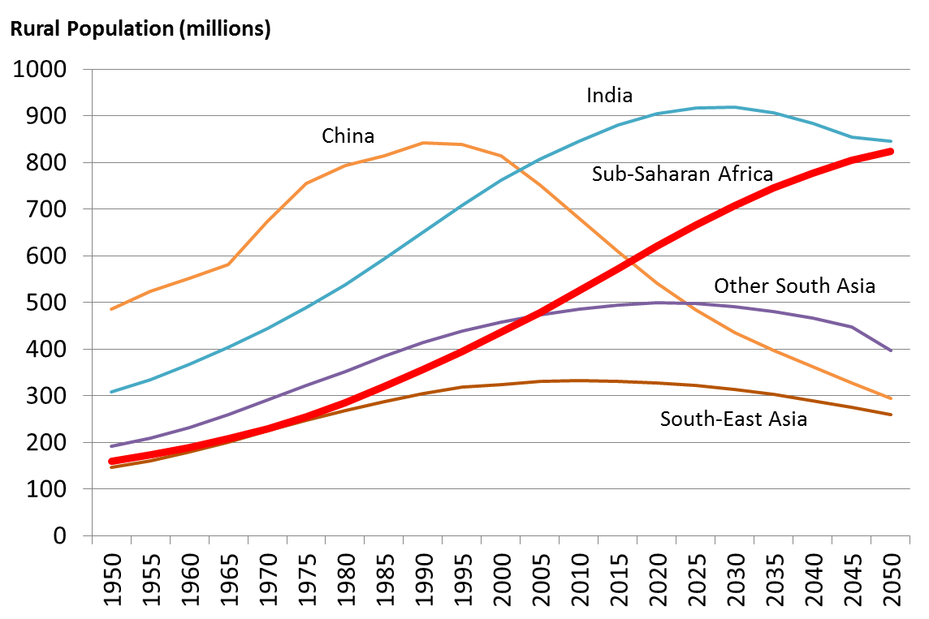

Source: Jayne et al. 2013

**Prognosis**

Should we expect much change in these patterns over the next 2-3 decades? Much will depend on rates of national economic growth and the non-agricultural employment intensity of that growth. But rapid farm consolidation does not necessarily follow from economic growth because of some of the constraints listed above. The earlier experiences of Japan, Taiwan, and South Korea suggest that in Asia the dominance of small farms could continue well into middle-income status (Otsuka 2013). In Japan, for example, the average farm size only started to increase quite recently despite the country’s rapid economic take off in the 1960s. And the average farm size was still only 1.8 ha in 2005, and the percentage of farms ≤ 3 ha was still 90.5 percent.

What we may see in the future is a widening bifurcation:

1. Between large numbers of small, part time farms and a modest but growing number of medium to large scale, commercial farms;
2. Between commercially oriented small farms that are well linked to value chains, and a much larger number of subsistence or nonfarm oriented farms; and
3. Between small farms in favorable areas with good market connectivity, and those in poorly connected and often marginal areas.

It is useful to think of four classes of farms for strategy purposes:

* Medium and large scale commercial farms. Family or corporate farms that are full time and typically hire labor.
* Commercial small farmers, who are already successfully linked to value chains, or who could link if given a little help. Many commercially oriented small farms are part time farmers.
* Small farms in transition, who have favorable off-farm opportunities and are at various stages of exiting farming as a serious business.
* Subsistence oriented small farms, are marginalized for a variety of reasons that are hard to change, such as ethnic discrimination, affliction with HIV/AIDS, or being located in remote areas with limited agricultural potential. Many of the same factors also prevent them from accessing nonfarm jobs and becoming transition farmers.

**Implications for the CGIAR**

Table 3 highlights the kinds of interventions that may be relevant for each of the three groups of small farms. Commercially oriented small farms need support as farm businesses. Transition farmers need help developing appropriate skills and assets to succeed in the nonfarm economy, including in many cases assistance in developing small businesses. Subsistence farmers are predominantly poor and will mostly need some form of social protection, often in the form of safety nets, food subsidies, or cash transfers. Interventions that help improve the productivity of their farms (e.g. better technologies and NRM practices) can make important contributions to their own food security and perhaps provide some cash income, and may in many cases prove more cost effective than some forms of social protection.

**Table 3: Types of assistance relevant for different small farm groups**

|  |  |
| --- | --- |
| *Type small farm* | *Types of assistance* |
| Commercial | **Farming as a business**  Better technologies and NRM practices  Organizing small farmers for marketing purposes  Incentivizing large agribusiness to link with small farms  Accessing seeds, fertilizer, finance and insurance  Securing land rights and development of efficient land markets  Encouraging entrepreneurship  Empowering women and other vulnerable groups  Building resilient farming systems  Safety nets |
| Transition | **Stepping out of farming**  Training and support for nonfarm activity, including development of small businesses  Encouraging entrepreneurship  Empowering women and other vulnerable groups  Securing land rights and development of efficient land markets  Better technologies and NRM practices  Safety nets |
| Subsistence | **Social protection**  Safety nets and transfers  Better technologies and NRM practices  Subsidized inputs for own food crops  Securing land rights  Building resilient farming systems  Empowering women and other vulnerable groups  Support for nonfarm diversification |

Where is the CGIAR’s comparative advantage? Ideally, the CGIAR would produce international public goods such as germplasm, NRM technologies and socio-economic policies that benefit all three types of small farms, plus medium and large scale commercial farmers. But more commonly, tradeoffs are involved, and not all farms can be helped through the same types of investments. Understanding these tradeoffs, and determining the priority target groups for the CGIAR are key issues for discussion.